EMERGENCY PROCEDURE 2017

1. An oscillated sounding of the emergency sirens indicates an immediate threat.

- All students/staff and visitors move to the back of the room they are in and get under the desks and cover their heads.
- Staff locks the door.
- Maintain position until instructed otherwise
- Snack or lunch on main campus - enter the nearest room and duck and cover.
- Big Field - find the nearest cover out of line of sight from the entrance.
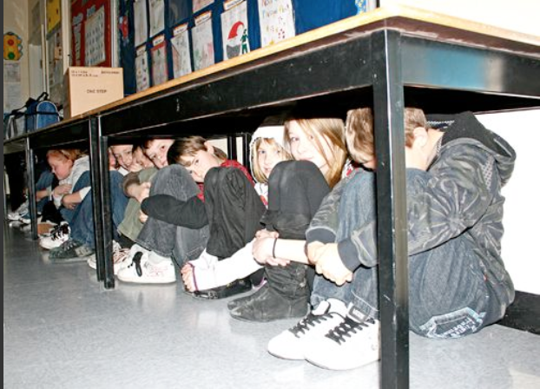

2. A long continuous sounding of the siren indicates Emergency Evacuation.

- Remain calm and quiet – follow administration instructions (either via PA or spoken)
- Move out of classrooms in single file
- Move towards the assigned collection point. Primary via Taman Bacaan/secondary via front gate.
- At the collection point take attendance and indicate status with green or red card.

3. Earthquake

- In the event of an earthquake all students/staff and visitors duck and cover under the nearest desk
- Remain in place until told otherwise.

